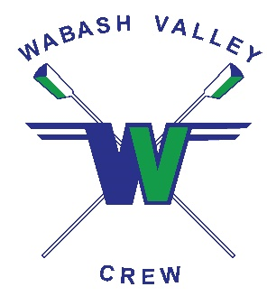
wabashvalleycrew.com
CREW TEAM MEMBERSHIP FORM
Full Name _________________________________________________________________
Date of Birth (mm/dd/yyyy) _____/_____/________ Male or Female (please circle)
Email address: _________________________________________________________________
School attending: _________________________________________________________________
Home address: _________________________________________________________________
Phone number: ________-________-____________
Emergency Contact – Full Name: ____________________________________________________
Emergency Contact Phone Number: ________-________-____________

Legal Guardian Name and Signature Granting Approval for Minor to Participate:
__________________________ ______________________ ____/____/_____
Printed Name Signature Date
Dues attached:
$585 one-time payment (before December 1, 2021) Check #: __________
Checks payable and mail to: Clara Fairbanks Foundation, Inc.
P.O. Box 11088
Terre Haute, IN 47801

Please include this completed form with payment write “WVC” on the check memo line

